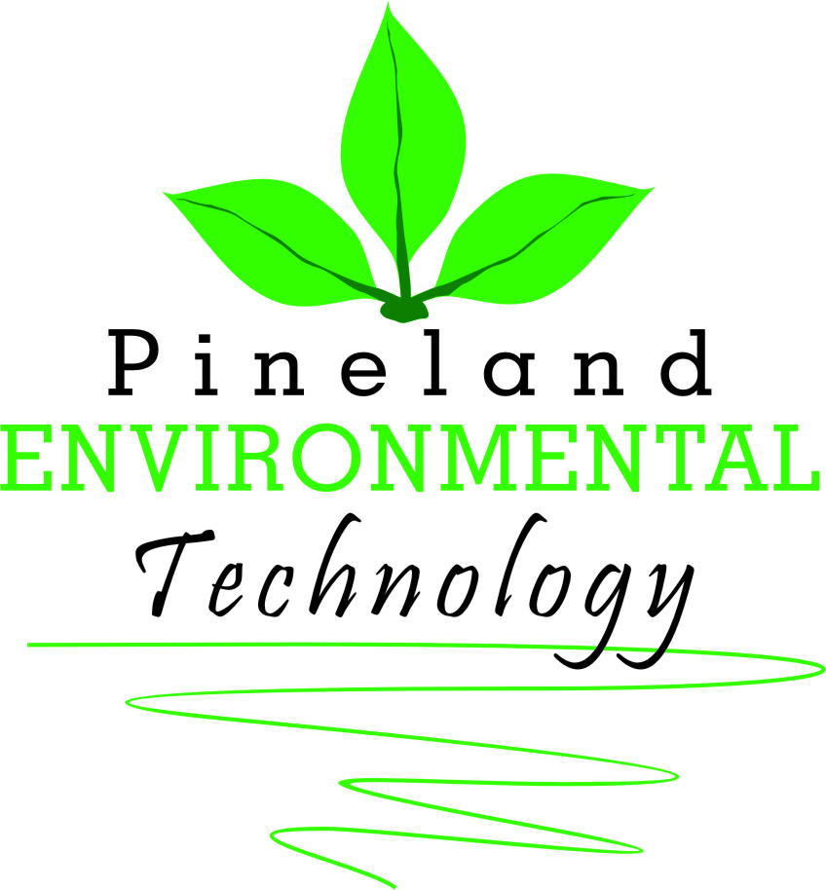
ULV SANITISER SPRAYFOG
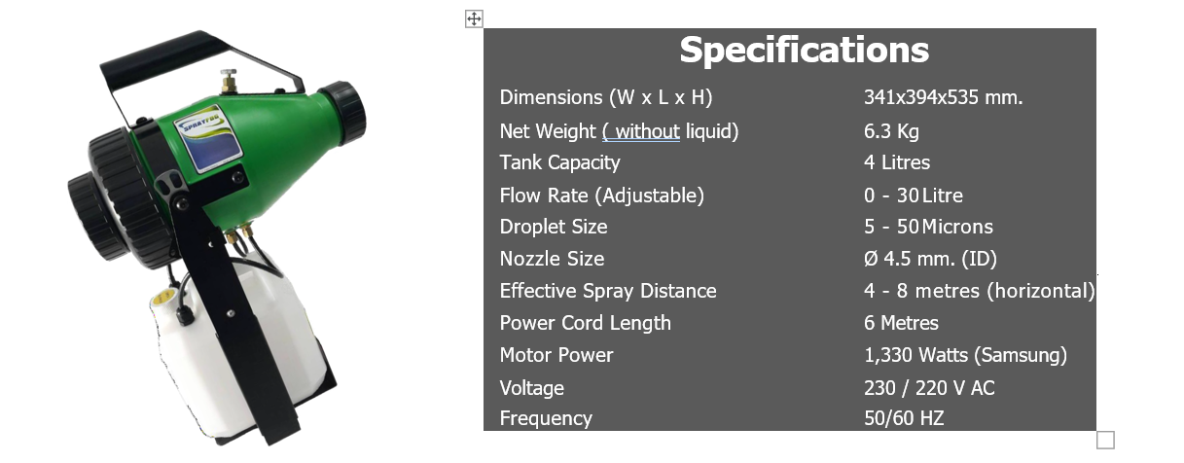

To be used with Hypo-Cleanse, a multi-purpose, non-toxic sanitizer.
See our website for more details.

Tel: +27 21 531 3749
Info@pineland.co.za www.pineland.co.za

